Generating Environmental Assets Accounts

Proof of Concept Documentation

FAME Economics

13 October 2025

# 1 Executive Summary

# 2 Background and context

# 3 Results

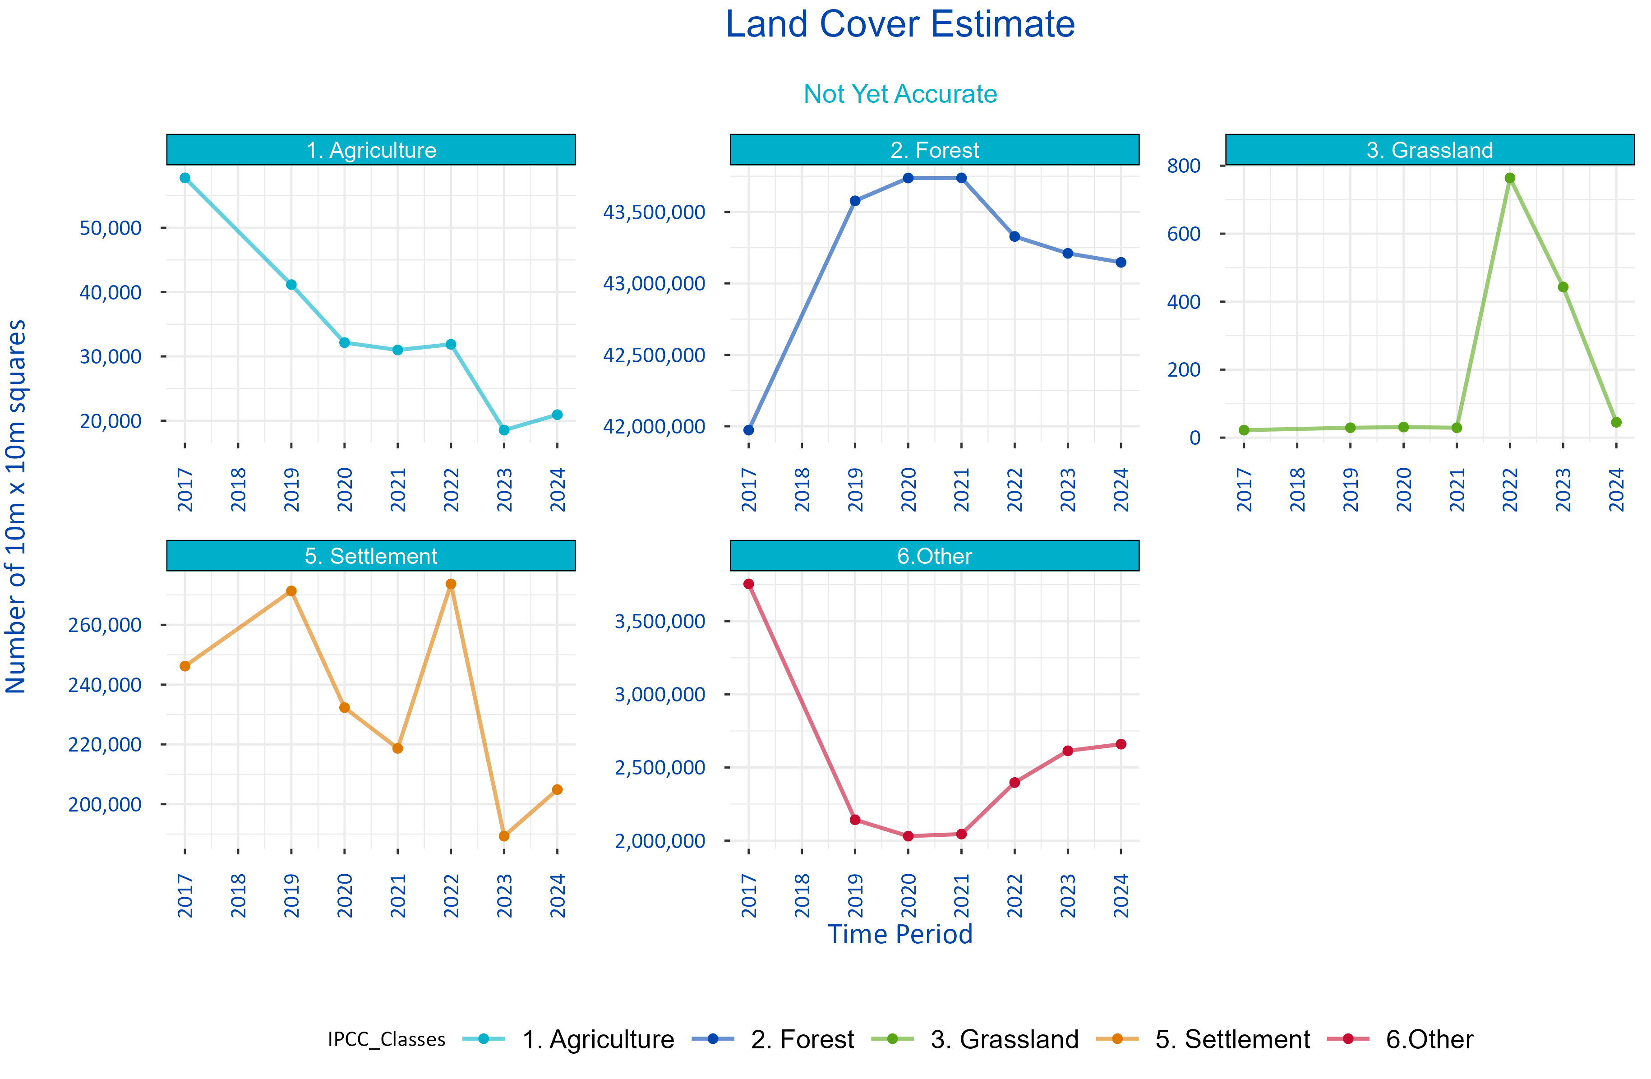

Figure 1: Experimental Land Use Metrics

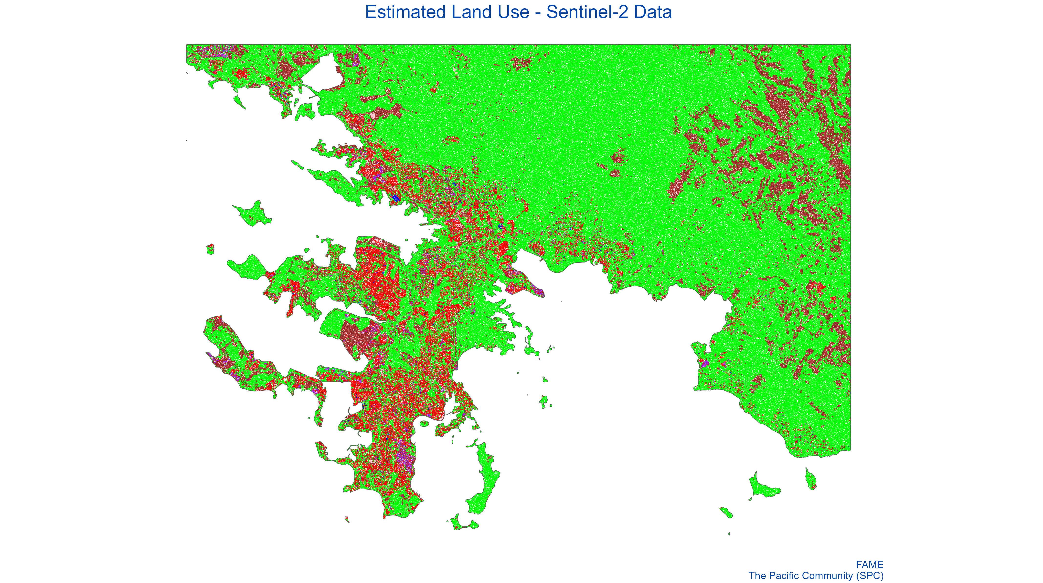

Figure 2: Estimated Land Use - Sentinel-2 Data

# 4 Methodology

# 5 Data Sources

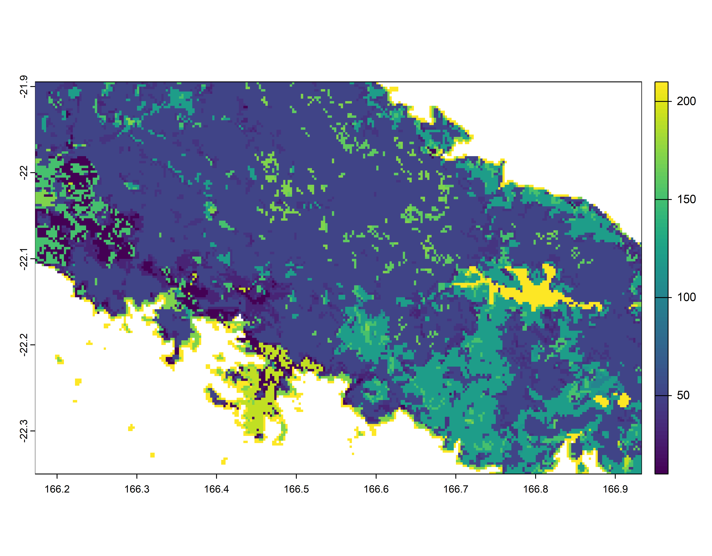

Figure 3: ESA Land Use Extract for Test Area

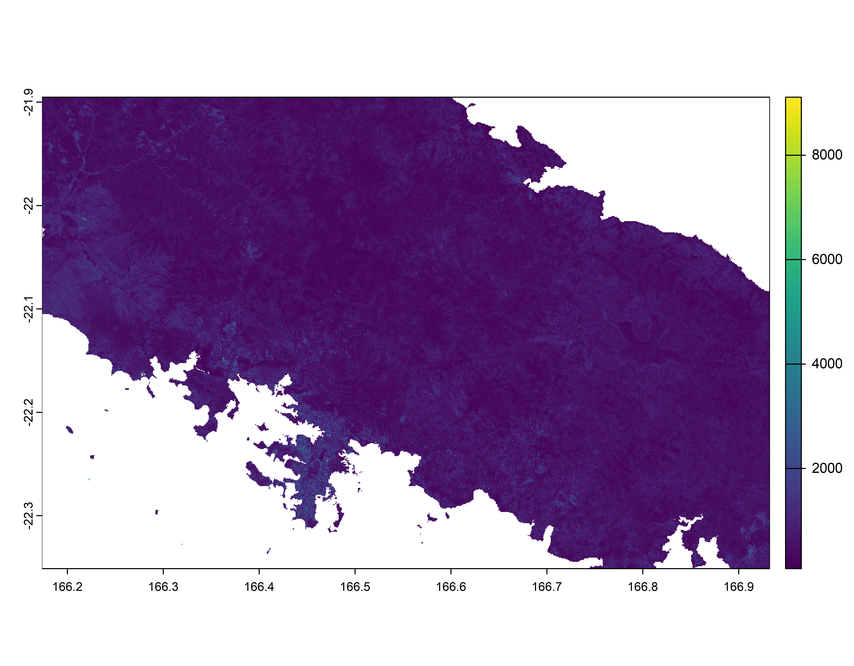

Figure 4: Sentinel-2 Colour Band

# 6 Issues

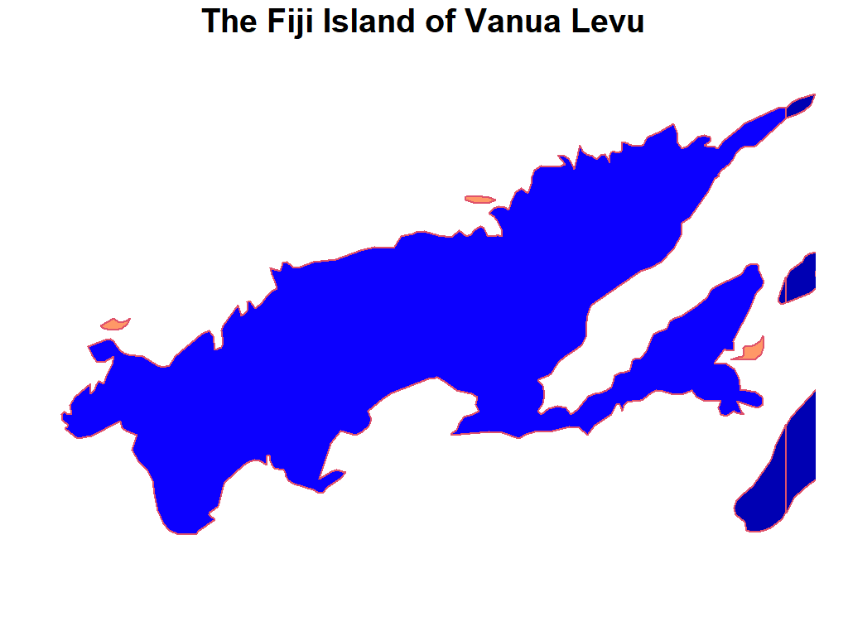

Figure 5: Vanua Levu as Shapefile

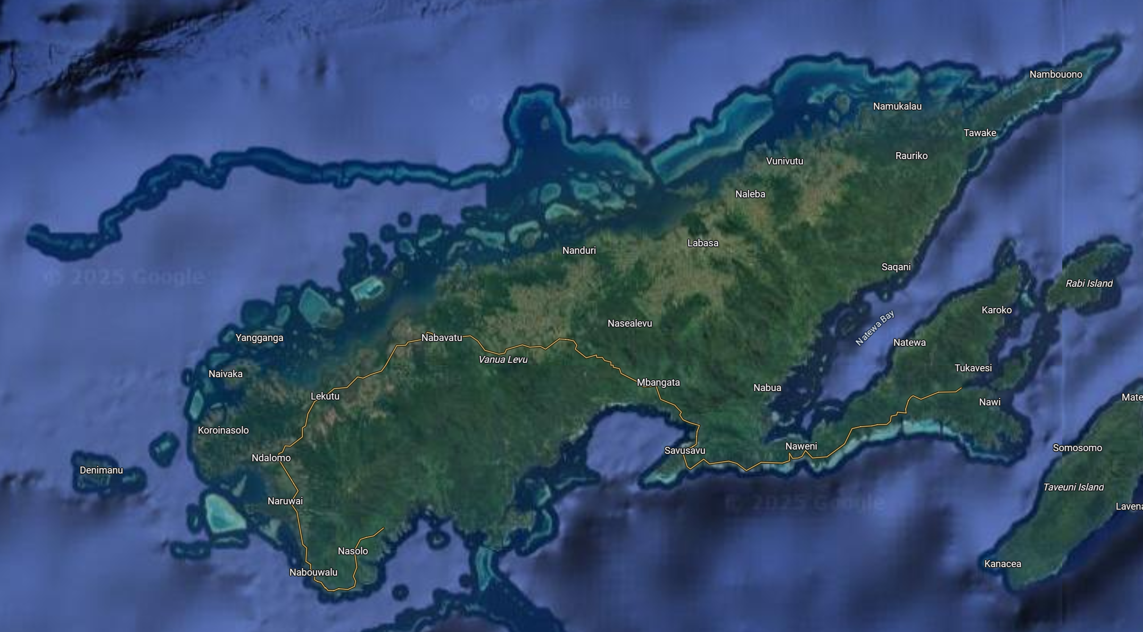

Figure 6: Vanua Levu in Google Maps

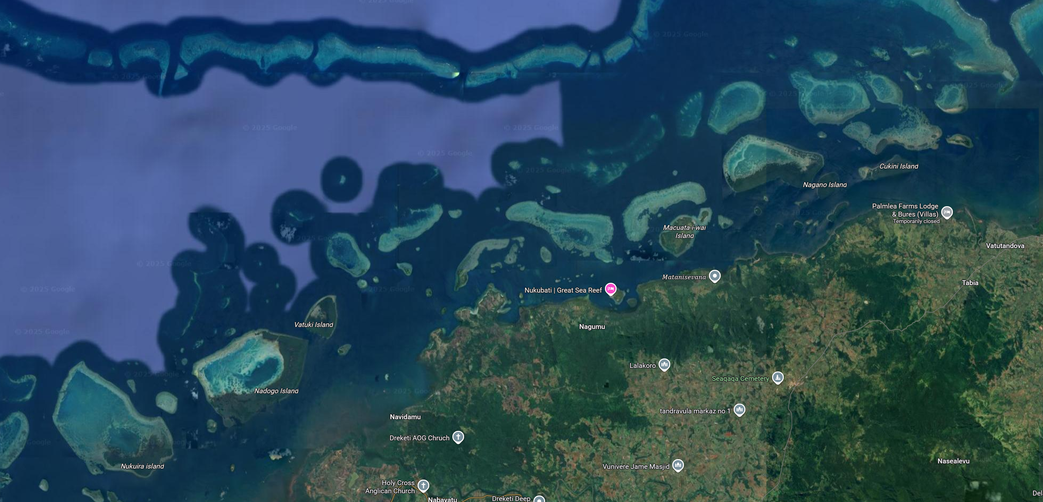

Figure 7: Vanua Levu Missing Spatial Complexity